Ercoupe 415-C
Pilot Operating Handbook

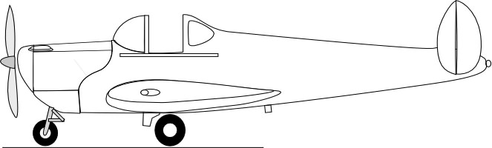

Contents

- General Information
- Operating Limitations
- Operating Instructions
  - Starting and Shutting Off Engine
  - Taxiing
  - Takeoff
  - Maneuvering in Flight
  - Cruising
  - Landing
  - Tying Down
  - Cross Wind Takeoff
  - Cross Wind Landing
  - Cockpit Checklist
- Service Inspection Instructions
  - Cleaning
  - Tires
  - Brakes
  - Control System
  - Propeller
  - Electrical System
  - Fuel System
  - Exhaust System
5. Appendix

January, 2013
This version of the Ercoupe POH was derived from the original 1946 Ercoupe 415-C "Instructional Manual" that was scanned to a PDF file and is posted on the www.ercoupe.info website. This version was produced by OCR scanning to produce editable text and graphics. It has been slightly edited to improve readability and add useful information. Performance and Operating Limitation data is based on the original Continental C-75 engine and propeller. Ercoupes with C-85, C90 and O-200 engines will perform differently.
GENERAL INFORMATION

The ERCOUPE is a two-place, low wing monoplane of metal construction. Power is supplied by a 75 horsepower Continental C-75 engine. Ease of ground handling is assured by the steerable nose wheel, excellent vision, and brakes.
Simplicity of flight has been achieved by eliminating the rudder pedals. Only the control wheel is used. Ailerons, rudders, and nose wheel are mechanically coordinated so that turns, both in the air and on the ground, are made by turning the control wheel right or left; the same wheel moved fore and aft controls the elevator. The ERCOUPE is certified by the Civil Aeronautics Administration as "characteristically incapable of spinning."

OPERATING LIMITATIONS
Required Information For 75-H.P. Model 415-C
Engine Limits 2275 RPM
Airspeed Limits 108 m.p.h. maneuvering speed
114 m.p.h. maximum structural cruising
144 m.p.h. never exceed
Maximum Weight 1260 lbs, 1320 lbs. with STC
Empty Weight _________________________________
Useful Weight _________________________________
Datum Forward face of firewall
Center of Gravity Range 26.4" to 30.3" rear of datum
Empty Center of Gravity _________________________________
Maneuvering No aerobatic maneuvers of any kind
Special Limitations This airplane is characteristically
incapable of spinning

OPERATING INSTRUCTIONS
Experienced operators will be acquainted with much of the material in this section, but because of the unusual features of the ERCOUPE, they, as well as new operators, are urged to become familiar with the following suggested operating practices.
- A check on the quantity of gasoline and oil in the tanks should be made before flying. All fuel tanks should be checked.
- A check that the brake is "on" should be made before starting the engine.
STARTING AND SHUTTING OFF ENGINE
The throttle should be closed, and with the header tank fuel valve turned on, the engine should be primed two to six "shots" depending weather. The ignition switch can then be turned to BOTH, the throttle opened slightly, about 1/8", and the starter engaged.
If the engine fails to start, the operation should be repeated. If the engine loads up or becomes flooded, the ignition switch should be turned off and with the throttle opened full, the starter should be held on to turn the engine several revolutions. Then the throttle should be returned to the position for normal starting, and with the switch turned to the BOTH position to start the engine, the starter should again be engaged. (This model engine is likely to load up or flood. Flooding can usually be detected by the odor of gasoline vapor near the air intake.)
After starting, the engine speed should be kept below 900 RPM, and the oil pressure watched. The gauge should show pressure within 15 seconds after starting.

TAXIING
Maneuvering on the ground is accomplished by merely opening the throttle sufficiently to cause the desired forward motion, and steering the nose wheel with the control wheel. To stop, the wheel brakes are applied by means of a foot pedal, or by means of a hand grip just below the throttle handle. The brake can be locked "on" for parking by turning the grip to a horizontal position.
If, while taxiing in an extremely high wind, if the airplane should have a tendency to weathercock into the wind, skidding the nose wheel somewhat against the pilot's control, improved traction and steering control can be obtained by keeping the control wheel forward, applying the brakes a small amount, and turning the handle to lock them if desired, and using greater engine power for taxiing.
Finally warmed up, the engine will turn approximately 2000 RPM standing still
TAKING OFF
For the take-off, there's a trim tab adjustment handle on the left side of the fuselage and above the pocket in the upholstery. The position indicator shows where to place the handle to trim for take-off. However, it can be left in the cruising position at take-off as the control forces are very light.
With its tricycle gear and nearly level wing, the ERCOUPE can be run along the ground at high speeds. To take off the ground, it is necessary to increase the angle of attack of the wing by lowering the tail, and this is usually done by moving the control wheel back gently after the minimum take-off speed has been exceeded by a comfortable margin.
The shortest take-off is ordinarily obtained by holding the control wheel full back throughout the entire take-off run. The tail will not come down until flying speed has been attained. The wheel should be eased forward after the plane leaves the ground, however, or the nose will point up too steeply for good climbing and it may drop again momentarily with some loss of altitude. It is advisable not to climb steeply after taking off, until an airspeed reading of at least 60 MPH has been reached, because the airplane will fly at a lower speed with full power than without power, and the engine might possibly fail with the airplane at less than its minimum flying speed without power.
In making a cross wind take-off, it is necessary to turn the control wheel some to overcome weathervaning (see page 12). As speed is gained and the ailerons actually begin to work, the upwind wing will rise. However, the pilot should continue to steer down the runway. The control wheel should not be pulled back too soon; be sure to have flying speed so that the plane leaves the ground completely. Neutralize the control wheel after the airplane breaks contact. The nose will normally swing and point upwind just about right to offset drift. The main thing is not to have the nose wheel lose traction before the airplane can fly, as it will then roll along on the rear wheels and turn into the wind.
MANEUVERING IN FLIGHT
After taking off, the steepest angle of climb to clear an obstacle is usually obtained at an airspeed reading of about 60 MPH. The best rate of climb for getting to altitude is obtained at an airspeed reading of about 70 MPH near sea level and the reading becomes lower as the altitude is increased, being about 60 MPH at 10,000 feet.
In flight without rudder pedals, turns are made simply by turning the control wheel until the proper bank is reached and at the same time keeping the nose in the position desired by adjusting the fore and aft position of the control wheel. The airspeed required in a steady turn is higher than in straight flight because the lift is not vertical and only the vertical component of the lift will support the airplane against gravity.
For example, the ERCOUPE, in a gliding turn with a 60⁰ bank and the control wheel full back, will show an airspeed reading of about 63 MPH as compared with about 45 MPH in a straight glide with the control wheel full back. Sharp turns naturally require steep banks with the control wheel well back.
If the airplane is in a power-off glide and the speed is gradually reduced by easing the wheel back, a mild jouncing or buffeting will be noticed at about 3 MPH above the minimum stall speed. This is caused by the burbling of the air flow at the juncture of the wing and fuselage, and has been designed into the airplane as an active warning that the minimum stall speed is being approached. The airplane will fly satisfactorily at minimum speed with the wheel all the way back in a glide, but the practice is not recommended at low altitude because no reserve energy is available to overcome the effects of gusty air or misjudgment.
If the control wheel is eased back gradually with power full on, the airplane will reach an uncomfortable nose-high altitude. In this condition, the flying will not be smooth or steady, but control can be maintained.
CRUISING
The airplane may be trimmed to cruise at any desired speed with a given throttle setting by adjusting the trim tab. In cruising flight, the nose of the ERCOUPE appears to be down unusually far, which gives good vision ahead. The cruising speed will be approximately 5 MPH higher with the windows closed. Therefore, to obtain the best possible cruising performance, the windows should be closed and the airplane should be flown at the highest altitude at which cruising RPM can be maintained, due consideration being given, of course to the wind and the weather
It is acceptable to cruise up to the red line placed on the tachometer dial at 2275.
The air speed meter indicates the true air speed within manufacturing tolerances for a definite cir density. This is the density found at sea level when the barometer reads 29.92 inches of mercury and the temperature is 59⁰ F.
The true air speed may be found with satisfactory accuracy by adding to the indicated air speed, 1 percent of itself for every 10⁰ above 59⁰ (or subtracting likewise for below)
For example, if the temperature is 89⁰ and the indicated air speed is 95 MPH, 1 per cent of it is .95 MPH and for 3 percent add 2.85 MPH, making the true air speed 97.85 MPH
For altitudes up to 10,000 feet, at 59⁰, add 1 per cent for every 500 ft. At 6000 feet add to this indicated air speed of 95 MPH, 12 x .95 or 11.40 MPH, making 106.40 MPH. Since the temperature at 6000 feet is 89⁰ the 2.85 MPH correction should also be added, making 109.25 MPH
There is also a correction for a change in barometric pressure. If the barometer at sea level is down 0.6” below the normal 29.92, another 1 percent is added. Therefore, if the barometer reads 29.62 at sea level, add .5 x .95 or .47 MPH to the 109.25 MPH, making 109.72 MPH the true airspeed.
The carburetor mixture control is operated by means of a push-pull knob on the instrument panel near the throttle. At altitudes above 5000 ft, the decreased density of the air may cause the mixture to become too rich for best power. This may be investigated by moving the mixture control from the full-rich position while checking the constant load RPM. If the RPM does not increase as the mixture is made leaner, the control should be returned to the full-rich position. For average operation below 5000 feet altitude, the carburetor should be left in the full-rich position. When at part throttle, the fuel consumption may be improved by leaning the mixture, but in no case should the control be moved far enough to decrease the engine RPM. The control should always be moved back to full-rich before any change in throttle setting
While cruising, the carburetor air heater is controlled by a push-pull knob on the instrument panel near the throttle. The engine should be operated with cold air at all times, except when under conditions where icing is likely, in which case the control should be placed in the full Carb Heat ON position
In cruising flight, the oil temperature will vary from 100⁰ F to
220⁰ F, depending upon the outside air temperature
LANDING
The mixture control should be placed in the full-rich position prior to the landing approach.
When the throttle is fully closed, carburetor air heat is applied automatically through a linkage connected with the throttle arm. From half throttle to full throttle, cold air is fed automatically to the engine However, a manual control is also provided and can be used to keep hot air feeding to the carburetor at more than half throttle setting when icing conditions prevail.
In glides, the cylinders should be cleared periodically by opening the throttle to cruising RPM to prevent spark plug fouling.
A good airspeed reading during the approach to a landing is one between 60 and 70 MPH. As the ground is approached the flight path is leveled off so as to reduce the vertical velocity. At the same time the airplane is flared in the conventional manner until it loses its flying speed. This practice is always advisable in case of rough terrain. However, the airplane may be set on the ground at up to twice the minimum speed, and as long as the control wheel is not pulled back, it will stay on the ground. After contact the wheel should therefore, either be held still or eased forward gently, preferably the latter.
If the airplane it glided in at an indicated speed that is too slow, it will be found that as it reaches the flareout point, the control wheel is already nearly all the way back and what is left doesn't check the descent soon enough to keep from landing flat and too hard. Even if the airplane is brought in with just sufficient speed to flare of the flight path under still air conditions, if a wind is blowing it may come down into a much more slowly moving layer of air close to the ground and have this induce a moderate dropping of the nose enough to nose it into the ground and thereby put excessive loads on the nose gear.
Either of these conditions can be checked (by immediately opening the throttle) and at the same time exercising care not to lower the nose by pushing forward on the control wheel. On the other hand, there is no point in steaming in at excessively high speed, even though the speed doesn't complicate things as it might were the air plane not landing level as it does on tricycle gear. It is therefore recommended that the normal approach speed be held to the suggested range of 60 to 70 MPH.
If, in the approach to landing, the pilot finds that he is overshooting slightly, he can nose the airplane down, remembering to level off and check the vertical velocity and put it on the ground immediately at a relatively high speed. With immediate application of the brakes, the landing will require decidedly less overall distance than it would if the airplane were held off the ground until minimum speed had been reached. Also, if the approach has been made at too high an altitude the flight path can be steepened by rolling the airplane from side to side, dipping each wing 20 or 30 degrees. If the altitude is sufficiently high this can be done satisfactorily with the wheel full back, and height is lost quite rapidly, but, because of the high vertical velocity attained, the airspeed reading should be increased to 60 MPH or above at an altitude of about 200 feet, and the flight direction should be held straight from about 50 feet altitude to the ground
In making cross wind landings, the airplane is headed or crabbed into the wind (See page 13). As the ground is approached the flight path is leveled off, and the airplane is held off the runway in the conventional manner until it loses flying speed.
Contact is made with the ground while the airplane is still crabbed and the nose automatically swings so as to line the plane up and permit it to continue moving in the direction in which it was moving in the approach. Therefore, at the time of contact the control wheel should be held lightly or momentarily released to permit this automatic adjustment. During the ground run, hold a little steering pressure on the control wheel to keep it from turning into the wind.
This brings up a change in point of view that it seems an experienced pilot of conventional airplanes must pass through before he can be satisfied with two control operation (without rudder pedals). He has been accustomed to controlling the attitude of his airplane about all three axes; as well as controlling the flight path and the speed. With two-control operation he must be willing to rely upon the stability of the landing gear to handle the drift in a cross wind landing. Not until he feels fully confident that the airplane itself will take care of this item satisfactorily and without strain, can he be expected to fly a two-control airplane with a feeling of comfort and pleasure.
In gusty air or in high winds in general, it is usually advisable to approach and land at a somewhat higher speed than in still air, and to have the airplane at all times either definitely in the air or definitely on the ground
After landing, the brakes may be used as desired. In an emergency they may be applied before the landing is made, but this procedure is not recommended as standard practice on account of the tire wear involved
Slippery terrain or loose gravel can bring on skidding during the landing run. If a tendency to skid and turn sort of sideways is noticeable, momentarily release the brake and it will straighten out and roll in the direction it was originally going. It's the same in a car. If the rear end starts skidding around to the right, turn right and immediately attempt to stop the skid.
TYING DOWN
Eyebolts are provided on the underside of each wing and on the tail cone for tying the airplane down when parked outdoors under questionable weather conditions. In tying down, the tail should be as well secured as the wings The eyebolts may be removed by unscrewing and can be carried in the glove compartment.

CROSS WIND TAKEOFF IN  AN ERCOUPE |  | START AT THE BOTTOM AN READ UP
In taking off cross wind, it is advisable to keep the control wheel well forward, which holds the nose wheel firmly on the ground and gives good steering control. Some excess in forward speed should be gained to allow the airplane to take off very definitely, and at the moment of breaking contact with the ground, the control wheel should be straightened laterally to a neutral position. The airplane may weathercock into the wind just after it leaves the ground but this need cause no concern as it is merely adjusting itself to true flight with respect to the air, and a straight course of travel is maintained without difficulty. The pilot should not hesitate to make slight turns near the ground in order to maintain the desired path and avoid being drilled off course by the wind. |  |  | 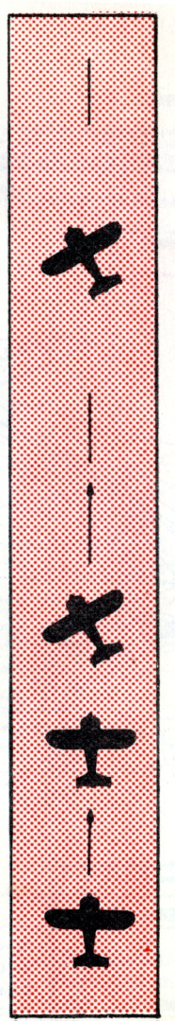
 | 4. A straight course of flight is maintained on the center line of runway during the climb. If the plane drifts sideways, make slight turns to get back to center of runway
 | 3. The airplane weathercocks into the wind just after leaving the ground. Wings are held level.
 | 2. Gain some excess forward speed and take off very definitely. At the moment of breaking contact, straighten the control wheel laterally to a neutral position.
 | 1. On ground run, keep forward pressure on the control wheel and some right control necessary to overcome weathervaning (tendency to head into the wind )
WIND FROM THE LEFT
CROSS WIND LANDING IN  AN ERCOUPE |  | START AT THE BOTTOM AN READ UP
In the approach to a cross wind landing, the airplane will be pointing up wind sufficiently to keep the flight path in line with the runway rather than attempt to drop the windward wing as is done in the three control plane. The glide should be continued in this crabbing attitude down until contact is made with the ground. At the moment of contact the airplane should be given its head, and the grip on the control wheel relaxed. This allows the nose wheel to caster and line up with the direction of motion of the airplane along the ground. Immediately thereafter, ease the control wheel forward slowly and roll down the runway. Prompt application of the brakes or setting the brake on about half way during the glide approach brings the nose down and completes the change in heading more quickly |  |  | 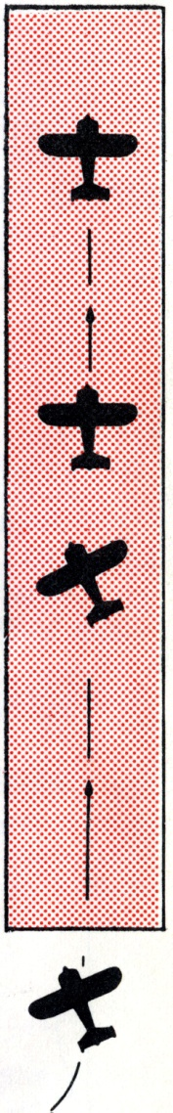
 | 5. During ground run steer like a car.
4. On ground plane will change heading to line up with path along runway.
3. Make contact decisively at low speed with plane still crabbed, but relax grip on control wheel to allow nose to caster and ease forward on control wheel slowly
2. If plane drifts sideways, make slight turns to get back to center line of runway
 | 1- Finish turn with Ercoupe on extended centerline of runway and headed or crabbed into wind just enough to keep its flight path (not heading} on the extended centerline.
WIND FROM THE LEFT

COCKPIT CHECK LIST
STARTING
- Check quantity of fuel and oil
- Both fuel valves ON
- Mixture—FULL RICH at all times
- Carburetor Air heat OFF
- Prime 2 to 6 strokes—Lock Plunger
- Throttle - Crack 1/8 inch
- Ignition on - Pull Starter
- Warm up - 900 to 1200 RPM
BEFORE TAKE-OFF
- Carburetor Air Heat Off (use full heat in icing conditions)
- Oil temperature - 90⁰ F min
- Oil pressure - >35 lb/sq inch (above 1900 RPM).
- Full throttle - 2000 RPM approximately
- Ignition Check - maximum 75 RPM drop on either magneto
and with Carb Heat
- Check for good idle
FLIGHT
- Oil pressure - >35 lbs
- Oil temperature range 100⁰ to 220⁰ F
- Adjust mixture control for best RPM (ABOVE 5000 FT.)
LANDING
- Mixture control- FULL RICH.
- Open throttle periodically in glide to clear cylinders
SERVICE AND INSPECTION INSTRUCTIONS
PARTS AND ADJUSTMENTS
Genuine ERCOUPE replacements parts are available only through authorized Distributors and Dealers. These representatives have a stock of the most needed repair parts and a file of information for the repair and adjustment of the ERCOUPE The nearest dealer may be determined from the list in the back of this book. He should be contacted for needed service.
The ERCOUPE owner should write the distributor or dealer in his territory and request that he be put on the mailing list to receive any special notice for ERCOUPE owners. This will assure him immediate advice should changes or modifications in his airplane be recommended.
The serial number on the nameplate fastened on the deck behind the baggage compartments should be included in all correspondence requesting information or parts for the ERCOUPE.
WINDSHIELDS AND WINDOWS
Flush off the excess dirt and grit with clear water and then use a soft, grit free sponge or open-mesh cheese cloth and mild soap. All rubbing should be done as lightly as possible to avoid scratching.
Do not use glass cleaning solutions, as they may contain solvents that are harmful to plastic.
ALUMINUM
Remove all loose dirt and grit from surface so that it will not be scratched when cleaner is applied. Wet a pad of Turkish toweling with aluminum cleaner and rub surface until cleaner has mixed with and absorbed all foreign matter. Wipe off remaining polish with a soft dry cloth.

OUTER PANEL WING COVER
The original high luster finish can be preserved, and the life of the covering can be lengthened by observing the following;
- Rinse off the excessive dirt with clear water and then wash with a mild soap.
- To restore the luster, polish with a mild rubbing compound and coat with wax (Avoid rubbing too hard on covering at sharp edges).
TIRES - MAIN WHEELS
It is necessary to remove the wheel hub cap to reach the valve stem for pumping up the tires In removing tire proceed as follows:
- Remove hub cap.
- Remove nuts that hold wheel halves together.
- Remove axle nut.
- Pry bead of tire loose.
- Remove outer wheel half and tire Leave inner wheel half remaining on axle.
TO INSTALL TIRE, REVERSE REMOVAL PROCEDURE
TIRE - NOSE WHEEL
In removing tire proceed as follows:
- Remove nuts that hold wheel halves together
- Have someone hold tail down to lift nose wheel
- Pry bead of tire loose
- Remove outer wheel half and tire. Leave inner wheel half remaining on axle
TO INSTALL TIRE, REVERSE REMOVAL PROCEDURE
BRAKE
The brake fluid reservoir is located under the hood on the firewall and should be kept nearly full of fluid. Excessive lost motion in the operation of the hand control should be eliminated by adjustment of the clevis at the end of the control wire. However, be sure that the master cylinder returns its full travel.
The brakes do not require adjustment of the lining surfaces.
To bleed the brake system
- Fill the reservoir with fluid.
- Remove the bleeder screw from fitting on one side only of the wheel brake assembly and place finger lightly over the hole.
- Have someone operate the brake control to full on" then hold finger over hole firmly and return control to "off" position. Allow a few seconds for the fluid to flow into the master cylinder and repeat the operation several times. Be sure to keep the reservoir full during this operation.
- Install the bleeder screw.
- Remove the bleeder screw from the other side and repeat operation (3)
- Install the bleeder screw.
- Continue bleeding until brake has a solid feel when applied.
Note: Do not allow hydraulic brake fluid to get on linings. Wash clean with carbon tetrachloride or naphtha.
CONTROL SYSTEM
To Check Control System Alignment:
- Neutralize the control wheels and check the control mast under the baggage compartment to be sure the arms are also neutral.
- This should place the ailerons in line with the wing airfoil section.
- In neutral, the nose wheel should also line up straight with the centerline of the airplane.
- Now check rudders (everything inneutral) using two straightedges paralleling the fin. Both should be straight.
- Elevator limits are fixed by contact of a stop ring placed on the control wheel tube with the instrument panel and should permit 13⁰ ± 1⁰ up travel. The up travel of the elevator is controlled by a turnbuckle which is sealed at the factory with a lead seal. This seal must not be broken except by an authorized ERCOUPE Service Station who will reseal it after making any necessary adjustment
STEERING LINKAGE
If shimmy occurs in the nose wheel while the airplane is running along the ground, it is an indication of looseness in the joints of the steering linkage, or of tire unbalance To eliminate the shimmy remove the excess play and balance the tire on the wheel
PROPELLER
The propellers approved for the ERCOUPE are the Sensenich design 74FCT 48 (for the taper shaft) and the 74FKT 48 (for the flanged shaft). Both are fitted with extra durable stainless steel leading edge tipping. Either propeller can be altered to fit the other type shaft, by a properly equipped shop.
Watch for signs of wear and dents on the leading edges or scratches which expose the wood and permit the absorption of moisture. Bare spots should be sanded and sealed with spar varnish. Moisture entering through exposed wood will cause roughness by disturbing the weight balance. Any large repair will require the propeller to be balanced and should be made by an approved repair station
ENGINE IDLING SPEED
After the engine is warmed, and with the throttle fully closed, the engine should maintain 650 RPM on the tachometer. With a lower idling RPM the engine may stop in a slow glide
MAGNETO AND SPARE PLUG CHECK
With the engine warmed, the magnetos should be tested separately for proper firing. Revolution speed of engine with full throttle should not drop off more than 75 RPM on either single magneto from operation with both magnetos. Prolonged full throttle operation on the ground should be avoided.

ENGINE COMPRESSION CHECK
While the engine is warm and with the ignition switch turned "off," pull the motor through four complete compression strokes to check for weak compression of any cylinder. An indication of poor compression should be checked with a competent engine man for his final decision.
Note: Do not pull engine through by hand immediately after running, as the engine may start
IGNITION SWITCH
The switch key is numbered and this number should be recorded in the log book for future reference in ordering duplicate keys.
FUEL SYSTEM
The engine driven fuel pump moves fuel from the wing tanks to the six gallon fuselage header tank. Excess fuel drains from the header tank overflow line back to the wing tanks. Fuel is gravity feed from the header tank to the engine carburetor. In case of fuel pump failure, the engine will continue to function until the six gallon header tank is empty.
The Main Fuel Valve is located approximately halfway between the brake handle and the pilot's control wheel shaft under the instrument panel. This main valve should be ON (lined up with down pipe) at all times except in case of an emergency.
The Wing Tank Shut-Off Valve is located on the right side skin forward of the seat. The valve handle should be ON (lined up with fuel line) and secured with a piece of brass safety wire. The only time this valve should be off is in a case of emergency or a malfunction. If the valve is turned OFF, the fuel cannot be pumped from the wing tanks to the header tank and the engine fuel supply and the remaining flying time, is limited to what fuel remains in the header tank.

Wing tank caps should be checked for good gaskets and functioning vent.
The wing tank gauge indicates the quantity of fuel in both wing tanks as a fraction of 18 gallons. The gauge is located close to the floor on the pilots side of the cockpit.
The header tank gauge, located forward of the windshield, is a visual check of the remaining fuel in the header tank. When the gauge is fully up there are six gallons in the tank. When it reaches the fully down position, at least one gallon should be left in the tank. Check the condition of the float frequently to ensure proper reading from this gauge.

FUEL SYSTEM

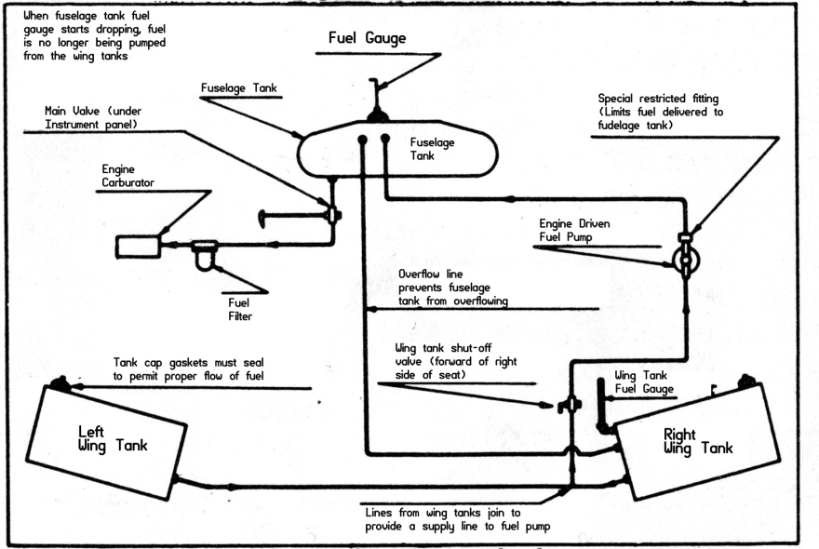
ELECTRICAL SYSTEM
A combination cutout and voltage regulator is used to control the generator output. The cutout relay is adjusted to start charging between 1150 and 1250 RPM depending upon state of battery, outside air temperature and speed at which generator is being driven. The charging rate which is near maximum alter starting, should diminish to two amperes or less within two hours of engine operation at cruising speeds. Lesser periods of time or charging rate indicate a favorable condition of the battery. The voltage regulator permits a maximum charging rate of 11 to 13 amperes. When the charging rate or time period exceeds those stated, the system should be checked to determine the trouble. That check must be referred to a specialist. Altering the voltage regulator will void the warranty on the regulator, generator, and battery, the owner must not tamper with this regulator.
The variable current output, as inducted in the preceding paragraph should be understood and periodically checked by the pilot during flight operation. Excessive charging at a high rate will boil the battery and cause serious damage. During all operation the master switch should be in the BOTH position. Failure to observe this practice will result in undue wear of the generator brushes. For the same reason, the airplane should not be operated with the battery disconnected or with a burned out fuse. The fuse located on the right hand side of the instrument panel protects only the generator output circuit and does not affect the light circuits which are protected by a circuit breaker incorporated in the navigation light switch
The level of electrolyte in the battery must be checked every 25 hours of operation, or at 30 day intervals if use is infrequent, distilled water should be added to keep level just below acid level indicator A hole in this indicator below the filler cap is provided to permit use of hydrometer. Filling this indicator will destroy the non-spill feature of the above battery. The battery electrolyte is extremely corrosive and should not be allowed to contact baggage compartment, structure, skin, or clothing.
Electrical System
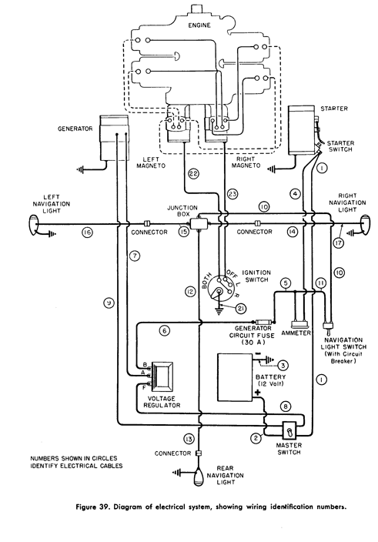

EXHAUST SYSTEM AND AIR HEATER CHECK
The exhaust pipes, muffler and cabin heater box should be examined for cracks that would allow the exhaust gases from the engine to enter the carburetor or cabin heater. Any crack permitting exhaust leakage should be repaired immediately.

APPENDIX:
- Ercoupe Inspection Report Forms
- Ercoupe Cruise Control Tables for C-75 and C-85
- Ercoupe Lubrication Chart (fold over to fit 5x7 size)

25 HOUR INSPECTION REPORT
Plane:__________________  Engine:_________________ | Date:__________________  NC:____________________
Use a checkmark for OK, an X for defective
ENGINE: Remarks
1. Drain Oil
2. Exhaust System
3. Ignition Wiring
4. Fuel Lines
5. Fuel Sediment Bowl
6. Carburetor and Air Intake
7. Bolts and Nuts
8. Engine Mount Fittings
9. Check Compression
LANDING GEAR:
1. Brakes
2. Tire Inflation
WINGS:
1. Inspect fabric or metal skin
2. Control Operation
TAIL CONTROL SURFACE:
1. Inspect Skin
2. Control Operation
FUSELAGE:
1. Inspect Skin
ACCESSORIES:
1. Battery
2. Avionics

100 HOUR INSPECTION REPORT
Plane:__________________  Engine:_________________ | Date:__________________  NC:____________________
Check all items under 25 Hour Inspection.
Use a checkmark for OK, an X for defective
PROPELLER: Remarks
1. Blades
2. Hub
3. Track
ENGINE:
1. Cowling
2. Exhaust System & Heaters
3. Spark Plugs
4. Magnetos
5. Fuel Tank Finger Strainers
6. Oil System Screen
7. Carburetor and Air System
LANDING GEAR:
1. Wheels
2. Shock Absorber Units
3. Brake Lines
4. Bolts and Fittings
WINGS:
1 Attachment Fittings
2. Hinges, Pins and Horns
2. Control Assembly
TAIL CONTROL SURFACE:
1 Attachment Fittings
2. Hinges, Pins and Horns
2. Control Assembly
FUSELAGE:
1. Control Assembly
2. Trim System
3. Cowling and Fairings
4. Safety Belts
5. Windows
6. Electric System

CRUISE CONTROL TABLES
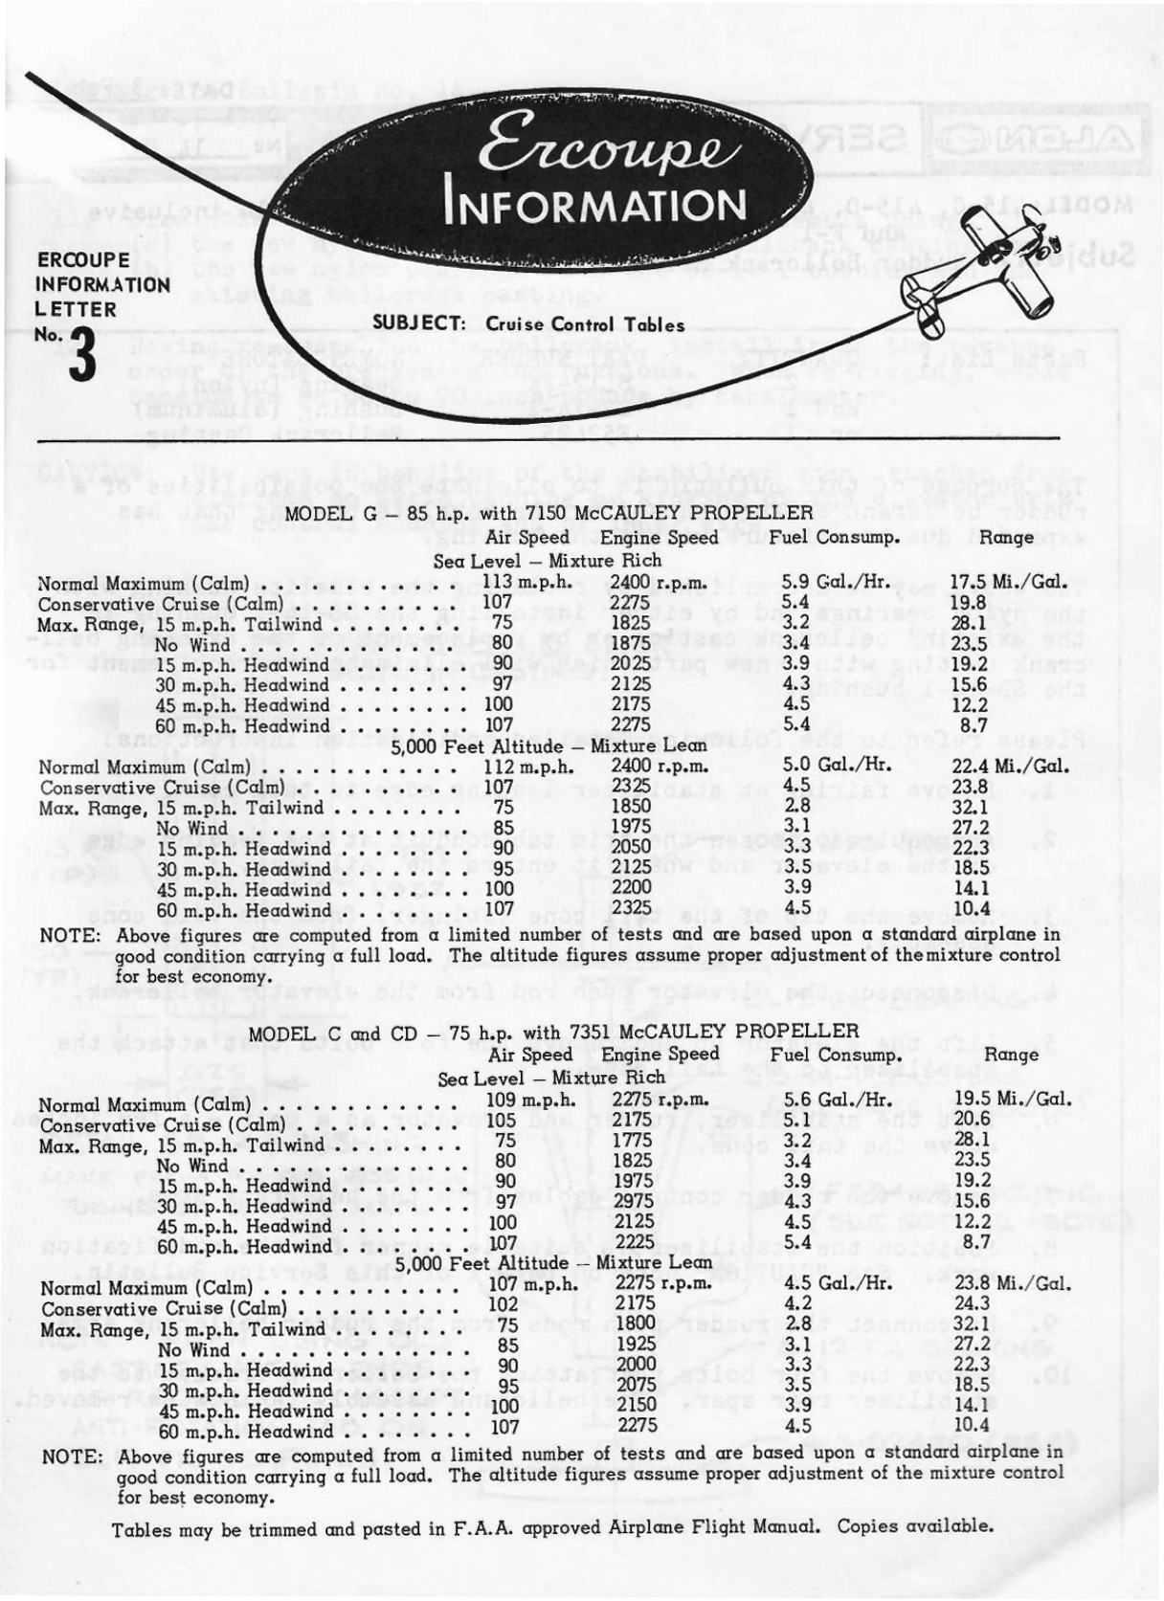

ERCOUPE LUBRICATION CHART